Q.1 Write a select command that produces the order number,amount and date for all rows in the orders table.

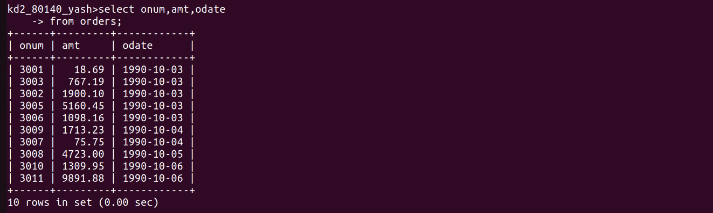

Q.2 Write a query that produces all rows from the customers table for which the salesperson’s number is 1001.

Q.3 Write a query that displays the salespeople table with the columns in the following order; city,sname,snum,comm.

Q.4 Write a select command that produces the rating followed by the name of each customer in San Jose.



